### CS 557: Computer Graphics Shaders

### Title: Final Project — Natural Scenery (Mountains & Water)

**Name**: Nirmit Patel

**Email**: [patenirm@oregonstate.edu](mailto:patenirm@oregonstate.edu)

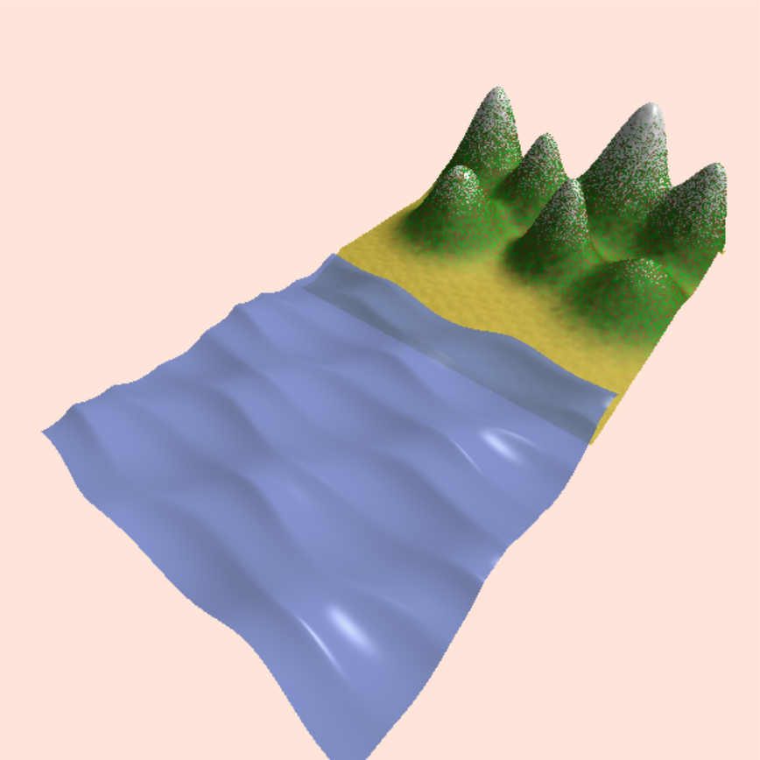

**Project Proposal**

**Project Title:** Noise Animation

For my Shaders Final Project, I propose to create an animated scene that incorporates noise, bump mapping, and displacement mapping to create a visually interesting and dynamic experience. The goal of this project is to learn more about these techniques and explore how they can be used together to create complex and dynamic visuals.

The scene will consist of several different objects, each with its own texture and unique noise pattern. The noise will be animated with different amplitudes and frequencies, giving each object its own distinct movement and behavior. Additionally, a flat object in the scene will have bump mapping and displacement mapping applied to it, which will be animated to create a dynamic texture. The camera will be set to move around the scene, giving the viewer a chance to see the different interactions between the objects and textures.

Overall, I believe that this project will be a challenging but rewarding experience that will allow me to further develop my skills in GLSL shaders. The use of noise, bump mapping, and displacement mapping will create a visually interesting and dynamic scene that will showcase the potential of these techniques. Through this project, I hope to create an animated scene that captivates and inspires viewers while pushing the boundaries of my own artistic abilities.

**Introduction:**

In this report, I will be presenting my final project, which is a natural scenery that includes mountains and water. To create this scene, I used a combination of exponential equations to create the mountains and sine-cosine equations to create waves in the water. I used three waves that move in different directions to create a realistic simulation of water movement. To get a better idea of how my project looks and works, you can check out the video link provided.

Originally, my project proposal was titled "Noise Animation," which involved using GLSL shaders to create visually dynamic effects with noise, bump mapping, and displacement mapping. However, I realized that I had already covered a lot of ground in that area and wanted to explore different techniques. I decided to use equations and lighting to create a natural scene instead. After experimenting with different equations and consulting with Professor Bailey, I found that exponential equations were the most effective in simulating the mountains. Professor Bailey's mention of different types of wave functions in class inspired me to explore the use of sine-cosine equations to create waves in the water.

In addition to the mountain and wave equations, I used bump mapping on the mountain's surface and created a random function that generates visually appealing green points on the mountain. I also used the same function in a different way to simulate snow. Overall, my project went through several iterations and changes from the original proposal, but I'm excited to share my final product and the techniques I used to create it.

**Video Link**: <https://media.oregonstate.edu/media/t/1_o79d51zt>

**Project Summary:**

In this project, I created a natural scenery that includes mountains and water using two separate programs, each working on individual quadrilaterals. The Mountains Program has two sliders: uDetails and uSnow. The uDetails slider adds green points over the mountain surface, with the value specifying the density of the points. The uSnow slider adds snow details to the mountain, with the value controlling the amount of snow from top to bottom. The Waves Program, used for the water, implements a wave effect on the quadrilateral.

To create the mountains, I used the exponential equation (height * e-k (x^2 + z^2)) (fig 1), suggested by Professor Bailey, as it provided the smooth ending I desired rather than the sharp ending in circular equation (x2 + y2 = R2) (fig 2). I then added lighting to the surface using normals and tangent vectors, with the binormal vector used to calculate the normal.

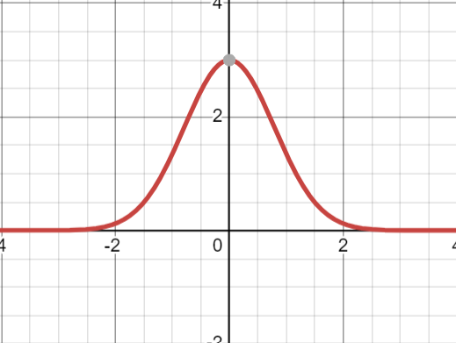 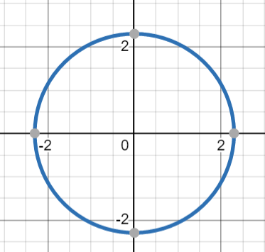

Fig 1 Fig 2

In addition to displacement mapping, I have also implemented bump mapping on the mountains quadrilateral. The use of bump mapping added an extra level of detail to the mountains surface, further enhancing the visual appeal of the scene.

For the water simulation, I referred to the Catlike Coding website for the wave equations and calculating the normal. To make the scene visually appealing, I blended the colors of the mountain using smoothstep() and mix() functions, with a sand-like color for the bottom, brown for the displaced surface, and white for the top snow effect.

To further improve the scenery, I utilized a random function to generate green points on the mountain surface and create a snow-like effect with varying densities. The snow texture was made more specular and shinier for a more realistic look.

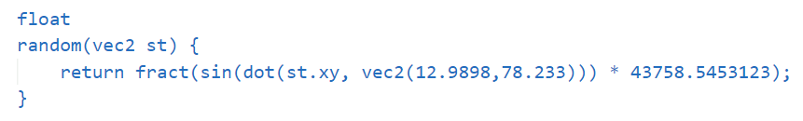

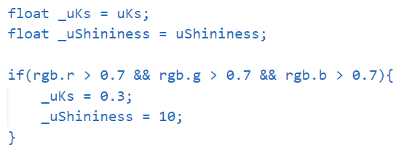

Overall, this project went through several iterations and changes, from the original proposal of using GLSL shaders for noise animation to the use of exponential and sine-cosine equations and lighting for a natural scene. The final result is a visually appealing and realistic simulation of mountains and water.

**Screenshots of the Project:**

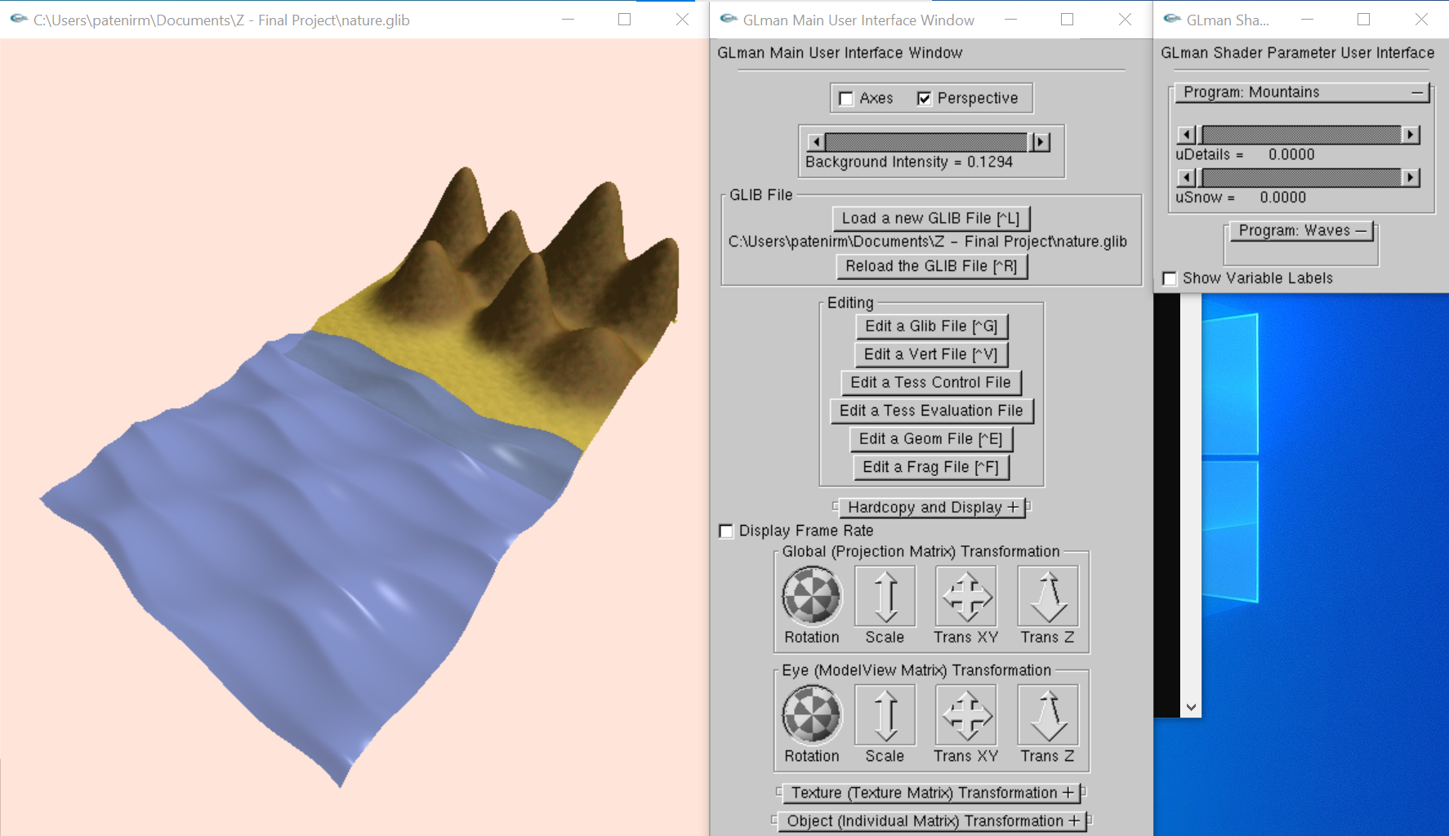

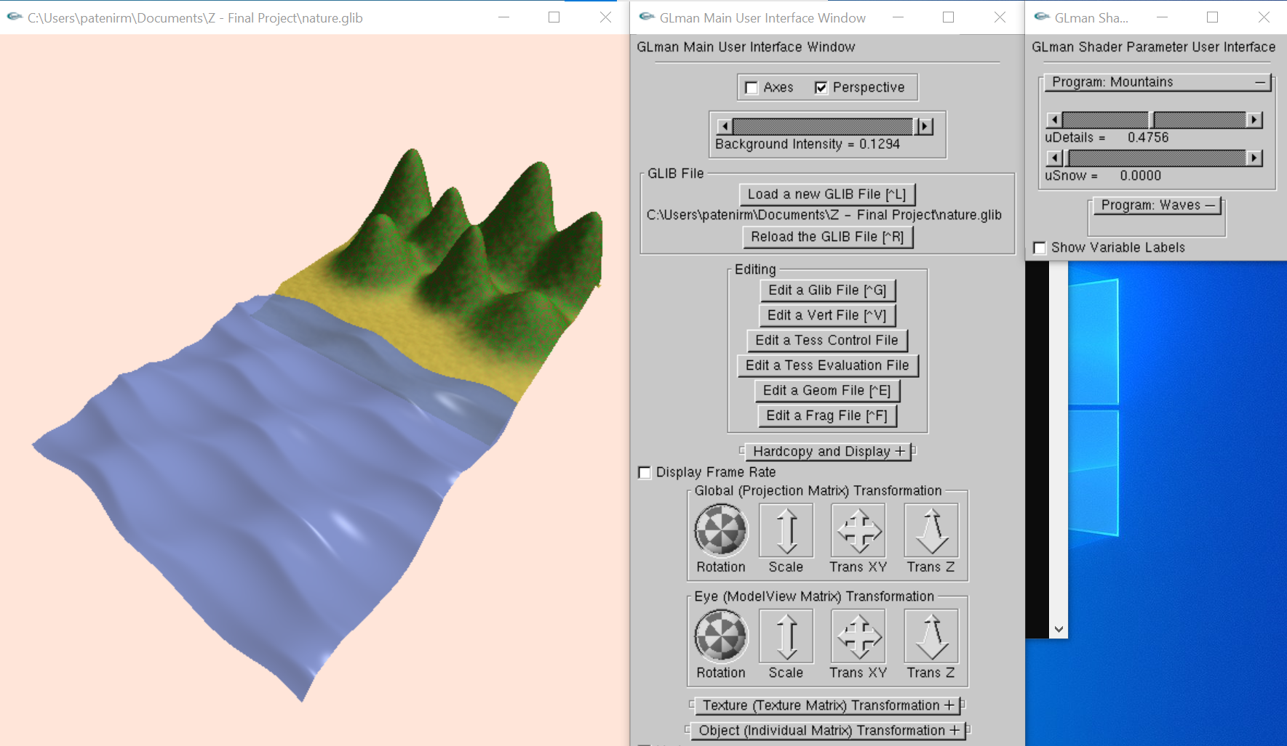

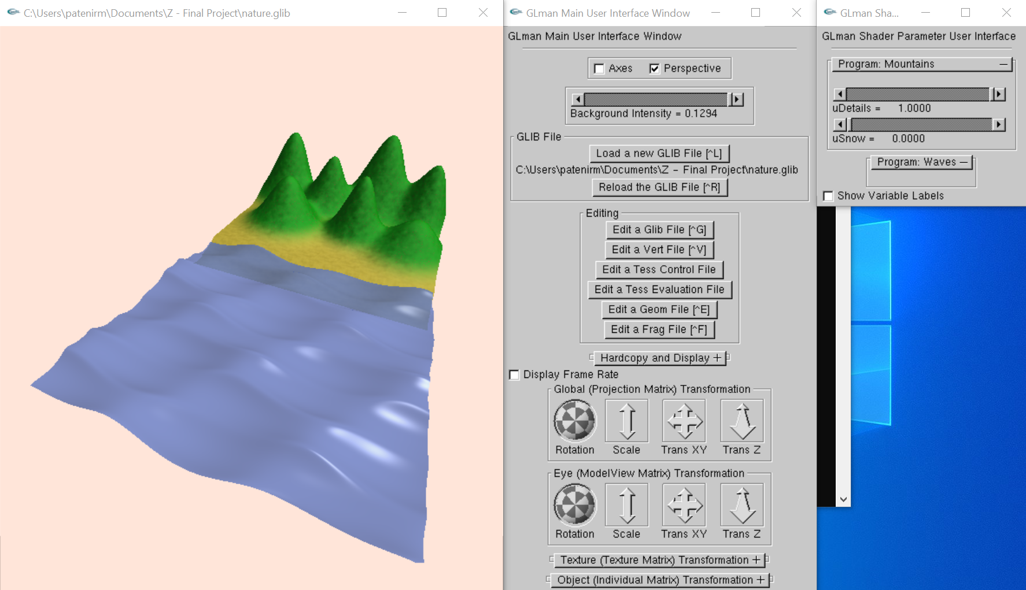

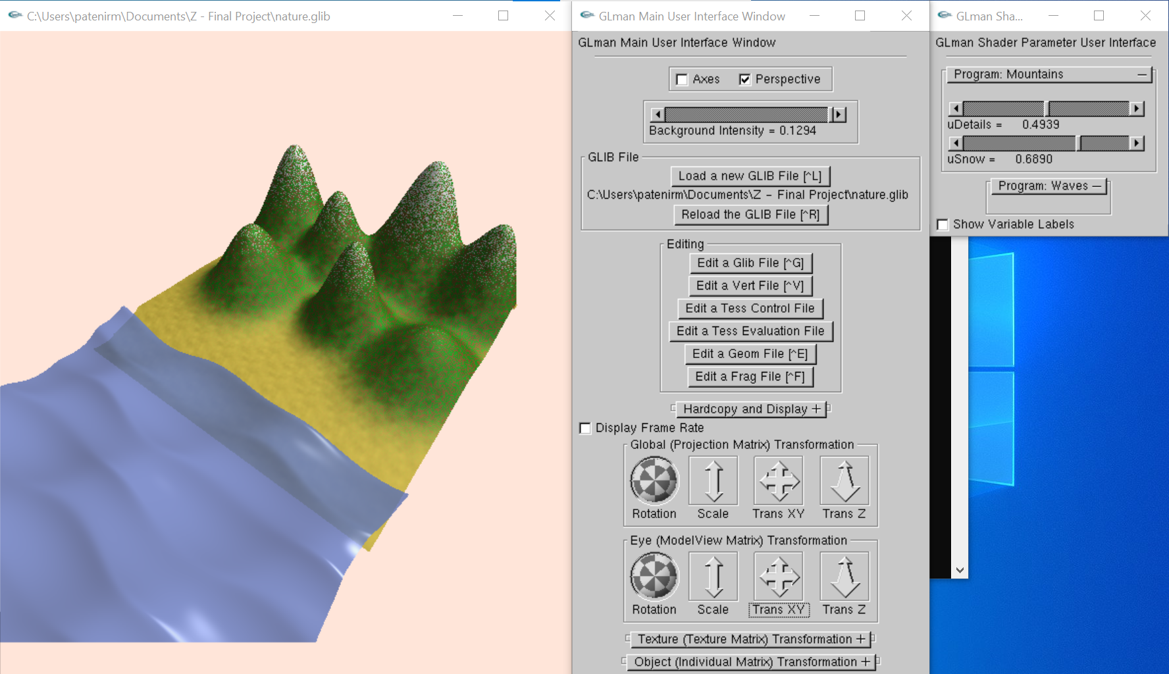

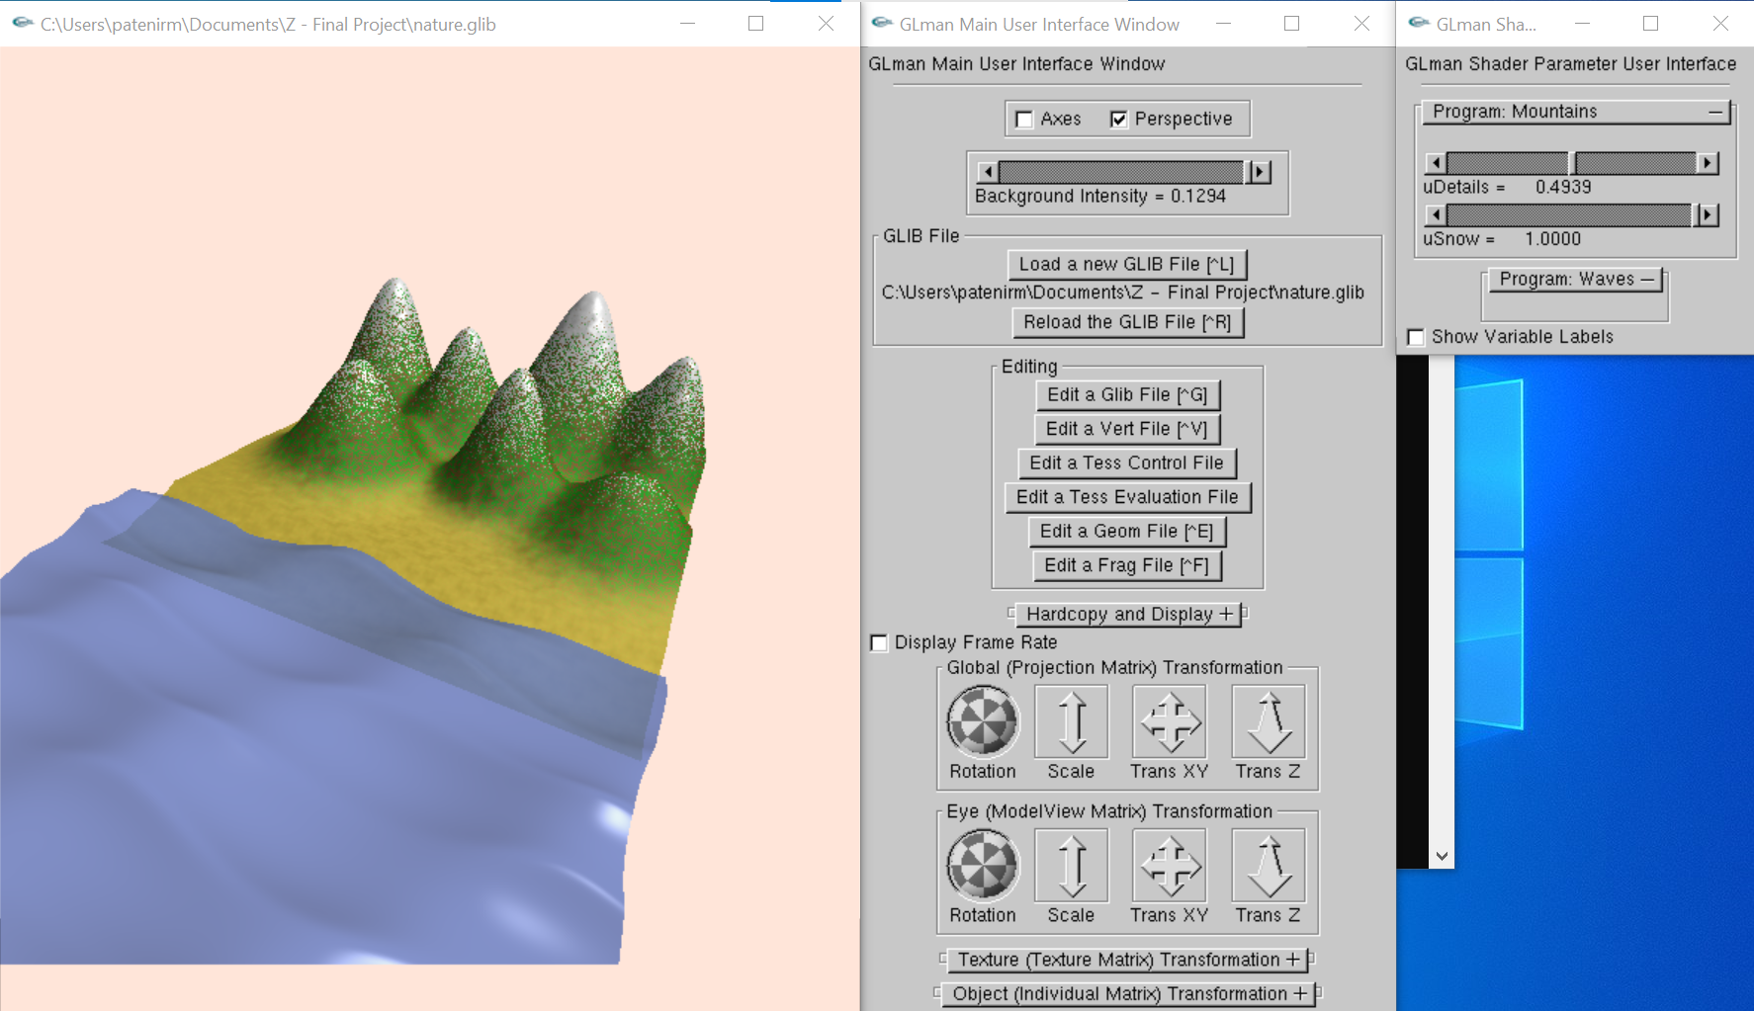

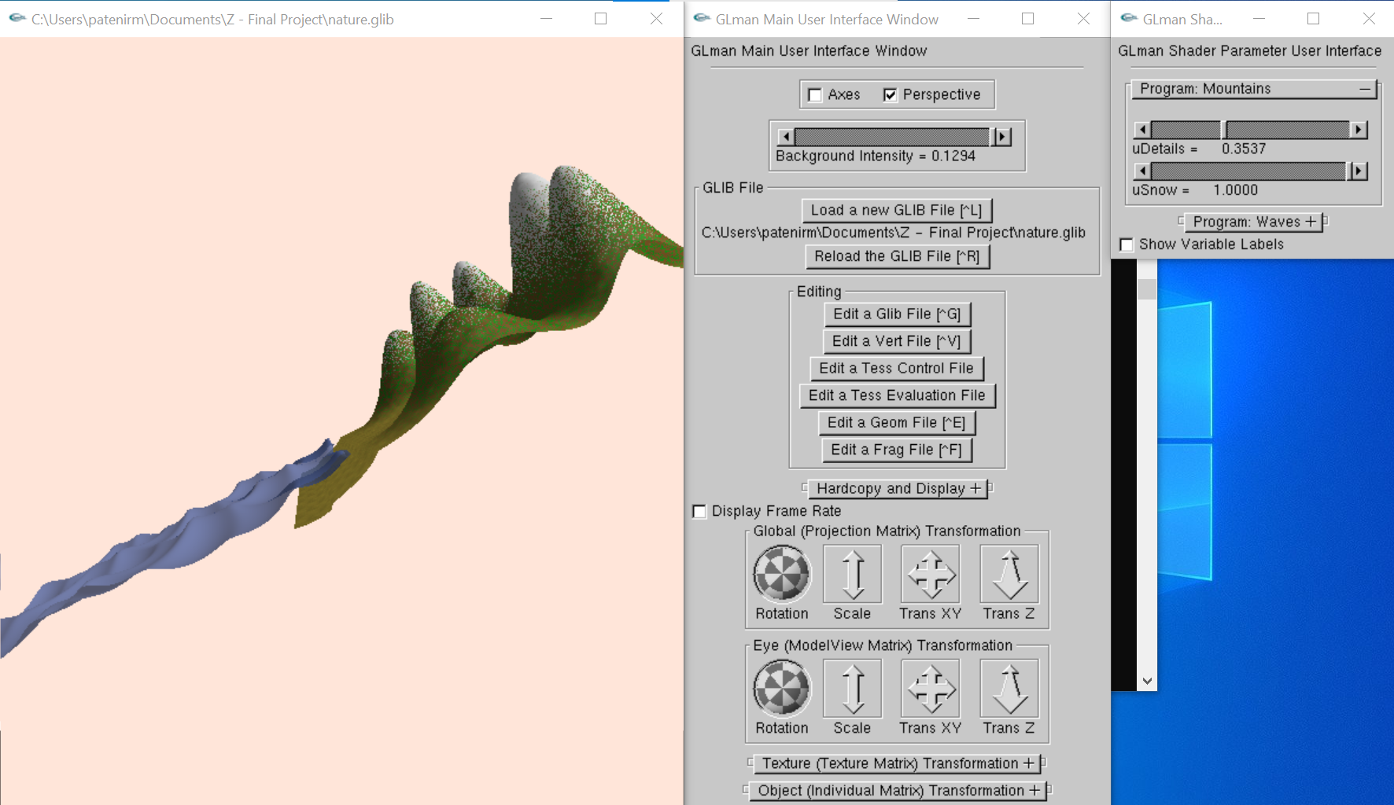

**Conclusion:**

In conclusion, this project was an exciting and rewarding experience for me. Through this project, I was able to explore and learn new techniques and concepts related to computer graphics, such as using equations for creating mountains, implementing bump mapping, calculating normals for lighting, and using the random() function for generating different effects on the surface. I also gained a better understanding of how to use different programs for graphics and how to create visually appealing scenes. Overall, I am extremely satisfied with the final result of the project, and I feel proud of what I have accomplished. This project has helped me grow as a programmer and has motivated me to continue exploring the world of computer graphics.

**References:**

* <https://catlikecoding.com/unity/tutorials/flow/waves/>
* <https://thebookofshaders.com/10/>
* <https://thebookofshaders.com/glossary/?search=smoothstep>
* <https://www.mathsisfun.com/calculus/derivatives-rules.html>